Online Application Tutorial

Step 1：Visit our Website
Please visit shanghai.nyu.edu and select the “Employee” portal tab in the upper right corner. Click the “Open Positions” link.

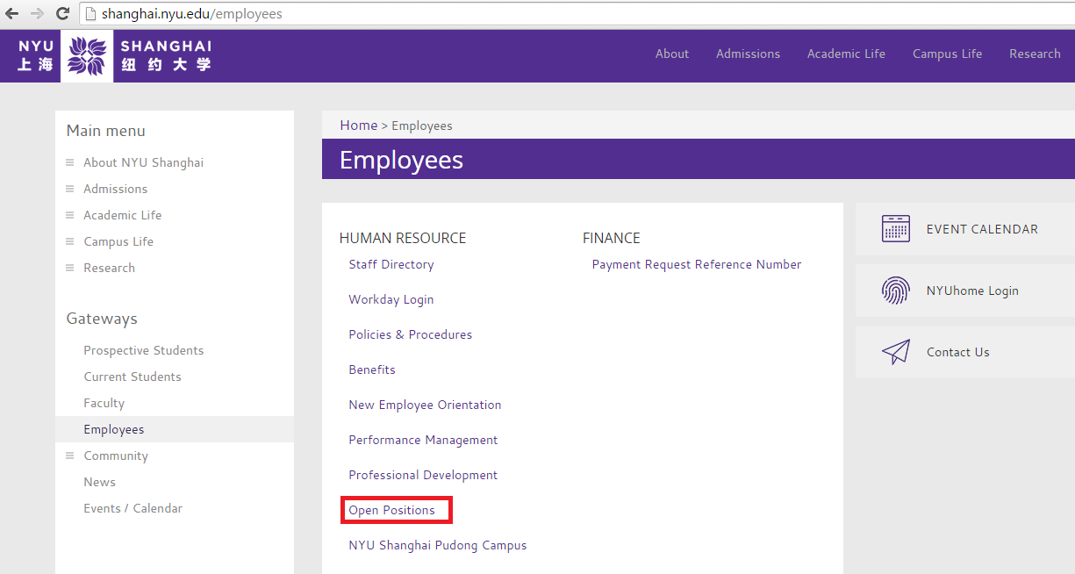

Step 2： Review Job Description and Apply
1. Review the job description for the position you’re interested in by selecting its PDF link.
2. Click “Apply” to proceed to that position’s application.
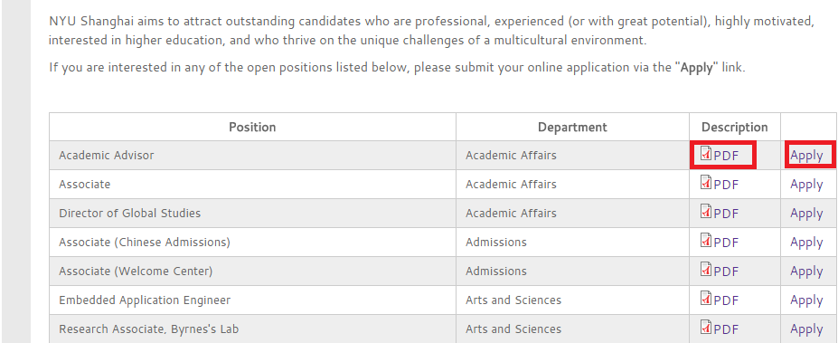
1
2
Step 3： Application Channel
Please select and complete the appropriate application for either Chinese applicants or International applicants.
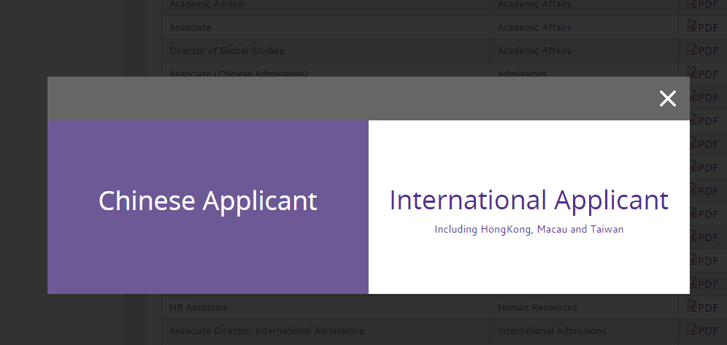

Step 4：Multi-Application
- If you would like to apply for more than one position, please select each relevant department and position in “Other Job Position(s).” The maximum number of positions you may apply for is five (5).
- Please follow the on-screen instructions and fill in all appropriate fields.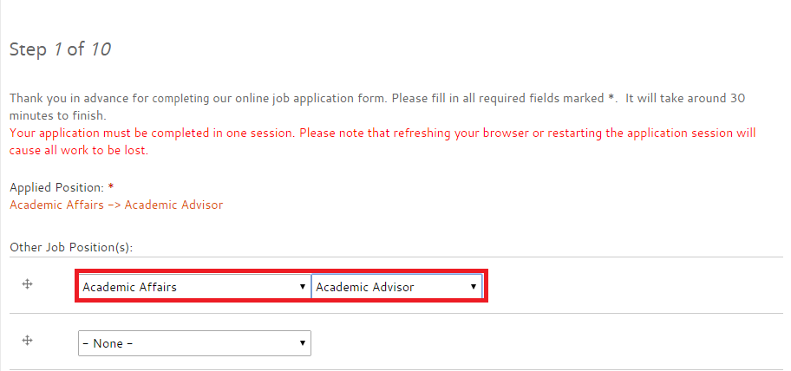

Step 5： Work Experience
Please use bullet points to list your primary job responsibilities when listing previous work experience.
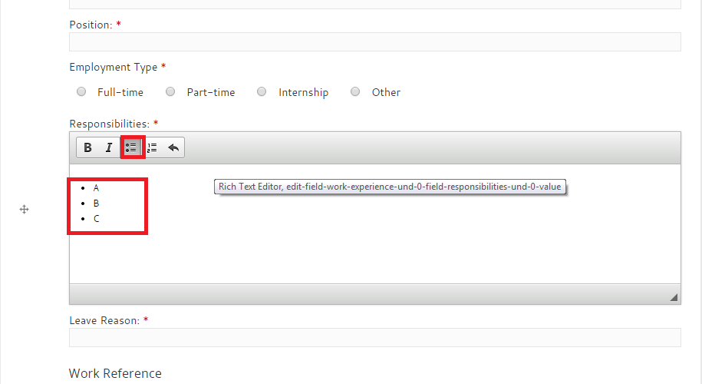

Final Step：Submission
Reminder：We will contact you if your experience and skills fit the position(s) you are applying for. If you do not receive an interview invitation within one month, your application has not been processed further. However, we will keep your application on file and contact you regarding future opportunities.
